SWE 363 – Web development

BE 1 Exercises

Part 1:

URL: <https://www.w3schools.com/>

The IP address: 192.229.133.221:443

Number of requests:

It was not fixed as I refreshed the page it seems to be changing. But mostly there was 69 requests. It might increase to 80 or more depending on different times it executes.

Different types returned:

There are many types, some of which:

1. Document
2. Git
3. Font
4. Jpeg
5. Script
6. Stylesheet
7. Svg+xml
8. Xhr
9. Text/html
10. Text/plain

Largest file returned:

The largest file is a JavaScript file with size 13.7 kB. The name of the file is: “usync.js”.

How many ms does it take:

The last loaded file took about 1.14s which is equal to 1140 ms. The name of the file is Fastlane.json.

Part 2:

The following is an image after following each step:

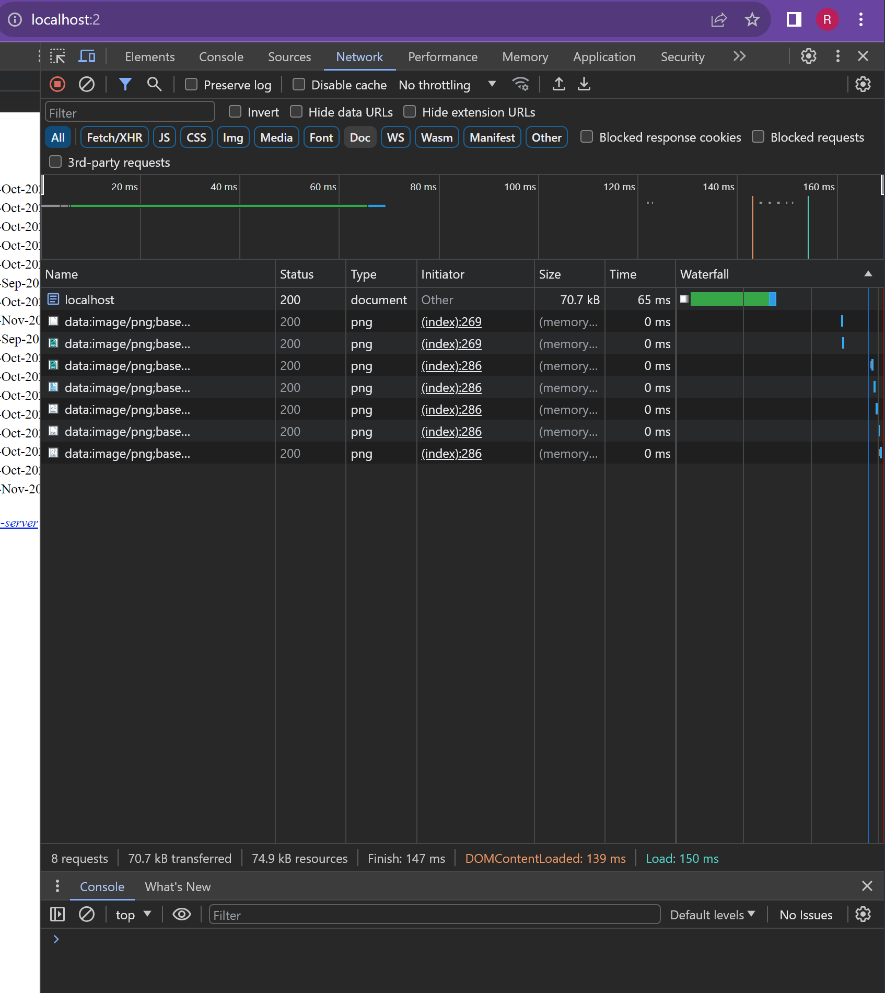

Part 3:

I found a domain name with my full name and I would like to choose it since it is perfect for my website idea:

